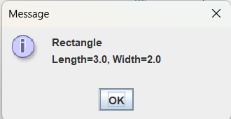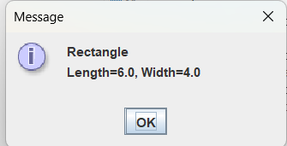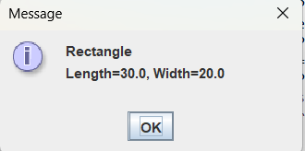

package as09;

//File: Rectangle.java
import javax.swing.JOptionPane;

public class Rectangle implements Status
{
private double length;
private double width;

public Rectangle(double l, double w)
{
length = l;
width = w;
}

public double getLength()
{
return length;
}

public double getWidth()
{
return width;
}

public String getStatus()
{
String status = "Rectangle\nLength=" + length + ", Width=" + width + "\n\n";
return status;
}

public void displayStatus()
{
String status = getStatus();
JOptionPane.showMessageDialog(null, status);
}
}

